1. **Update status:**

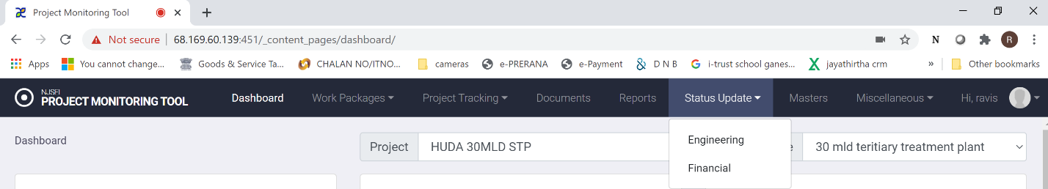

Click on “update status” in main menu and choose “engineering” in the screen above and you will see options as shown below.

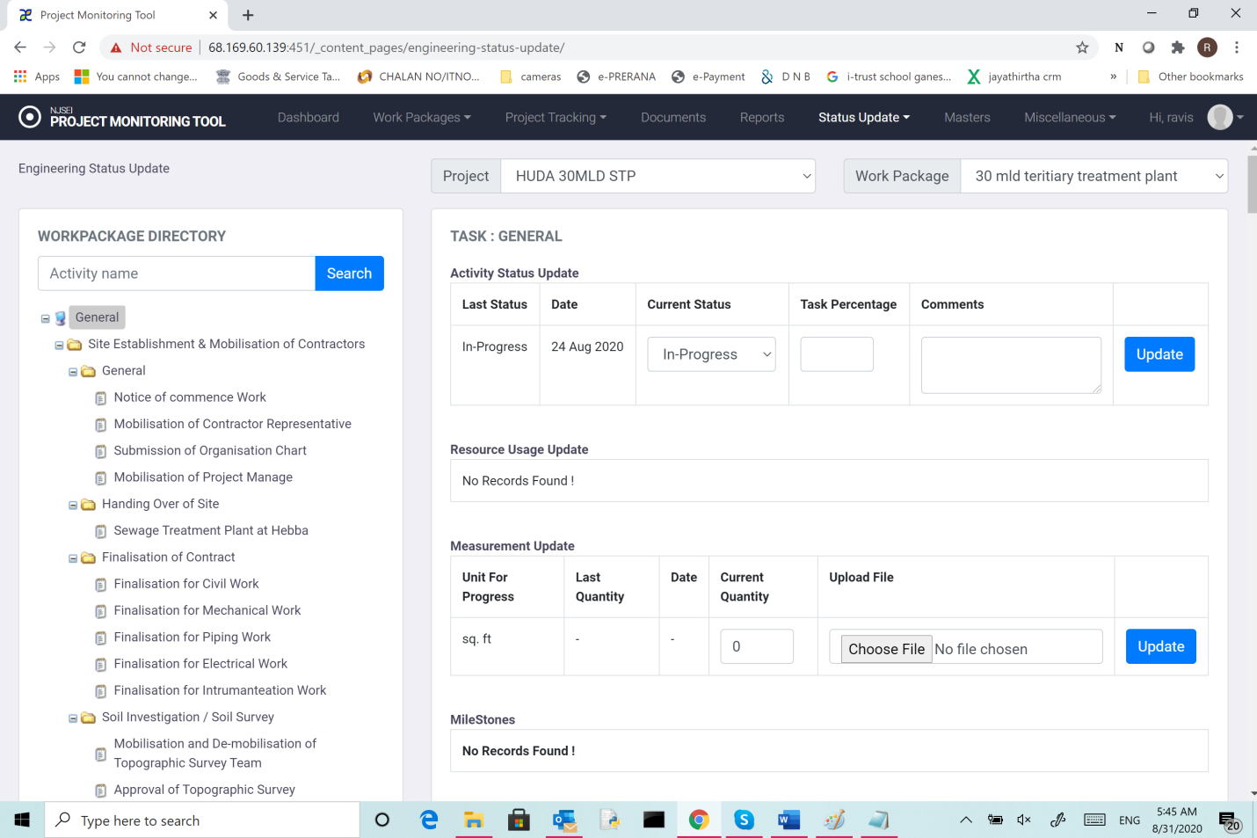

This screen helps update all aspects of a chosen task.

* + 1. Activity status:

1. Choose the new status from drop down.
2. Enter % task completed (if that is required and doable).
3. Enter any relevant comment and click “update”.
   * 1. Resource usage update:
4. Enter current usage and click “update”.
   * 1. Measurement status update:
5. Enter current usage .
6. Choose any file to upload (can be a picture of the site/construction.
7. Click “update”.
   * 1. Resource usage update:
8. Enter current status and click “update”.

To check the updated status.

1. Click “work package in main menu,
2. Choose Engineering.
3. In the tree view click on the sub-activity and right panel will show updated status.

